Q: Define research and its types?

**What is Research?**

**Definition:**Research is defined as careful consideration of study regarding a particular concern or problem using scientific methods. According to the American sociologist Earl Robert Babbie, “research is a systematic inquiry to describe, explain, predict, and control the observed phenomenon. It involves inductive and deductive methods.”

Inductive research methods analyze an observed event, while deductive methods verify the observed event. Inductive approaches are associated with [qualitative research](https://www.questionpro.com/blog/qualitative-research-methods/), and deductive methods are more commonly associated with quantitative analysis.

Research is conducted with a purpose to:

* Identify potential and new customers
* Understand existing customers
* Set pragmatic goals
* Develop productive market strategies
* Address business challenges
* Put together a business expansion plan
* Identify new business opportunities

**What are Research Types?**

Classification of research types and description.  
The basic types of research are as follows:   
**Descriptive vs Analytical Research:**

***Descriptive Research:***  
  
Descriptive research includes surveys and fact-finding enquiries of different kinds. The major purpose of descriptive research is description of the state of affairs as it exists at present. The main characteristic of this method is that the researcher has no control over the variables; it can only report what has happened or what is happening.  
The descriptive research method is basically divided into three types-

* Observation Method
* Case Study Method
* Survey Method

***Analytical Research:***

In analytical research, the researcher has to use facts or information already available, and analyze these to make a critical evaluation of the material.  
There are different types of Analytical research methods available. They are,

* [Regression Analysis approach](https://research-methodology.net/research-methods/quantitative-research/regression-analysis/)
* Grouping Analysis approach
* [Multiple Equation Methods](https://www.sciencedirect.com/topics/economics-econometrics-and-finance/multiple-equation-model)

**Applied vs Fundamental Research:**

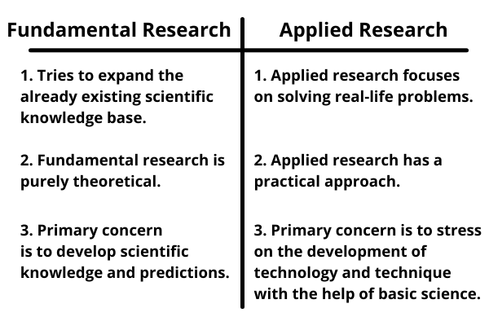Applied vs Fundamental Research

You should read – [What is Research? Research Methods vs Research Methodology, Research Methods vs Research Techniques](https://techvalo.com/research-methods-vs-research-methodology-research-methods-vs-research-techniques/)

***Fundamental Research:***

* Fundamental research can be explained as research that tries to expand the already existing scientific knowledge base.
* Fundamental research is purely theoretical.
* The applicability of fundamental research is greater than the applied research, in the sense that the former is universally applicable whereas the latter can be applied only to the specific problem, for which it was carried out.
* The primary concern of the fundamental research is to develop scientific knowledge and predictions.

***Applied Research:***

* Applied research is used to mean the scientific study that is helpful in solving real-life problems.
* Applied research has a practical approach.
* The primary concern of the applied research is to stress on the development of technology and technique with the help of basic science.

**Qualitative vs Quantitative Research:**

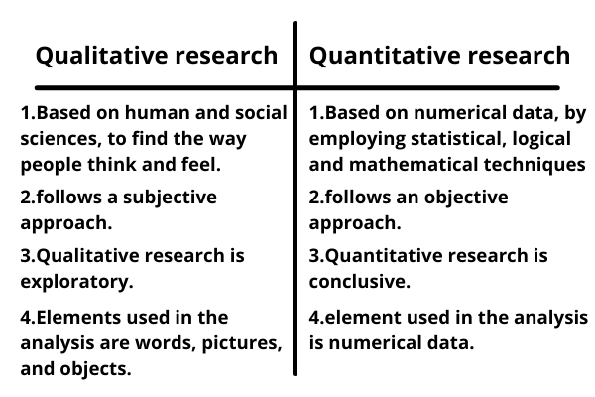

**Qualitative vs Quantitative Research**

***Qualitative Research:***

* Qualitative research is a method of inquiry that develops understanding on human and social sciences, to find the way people think and feel.
* The qualitative research follows a subjective approach as the researcher is intimately involved.
* Qualitative research is exploratory.
* The reasoning used to synthesize data in qualitative research is inductive
* Elements used in the analysis of qualitative research are words, pictures, and objects.
* Qualitative Research is conducted with the aim of exploring and discovering ideas used in the ongoing processes.
* Lastly, the methods used in qualitative research are in-depth interviews, focus groups, etc.
* Qualitative Research develops the initial understanding.

***Quantitative Research:***

* A scientific and empirical research method that is used to generate numerical data, by employing statistical, logical and mathematical technique is called quantitative research.
* The approach of quantitative research is objective, as the researcher is uninvolved and attempts to precise the observations and analysis on the topic to answer the inquiry.
* Quantitative research is conclusive.
* The reasoning used to synthesize data in quantitative research is deductive.
* An element used in the analysis of quantitative research is numerical data.
* The purpose of quantitative research is to examine cause and effect relationship between variables.
* Lastly, the methods of conducting quantitative research are structured interviews and observations.
* Quantitative research recommends a final course of action.

**Conceptual vs Empirical Research**

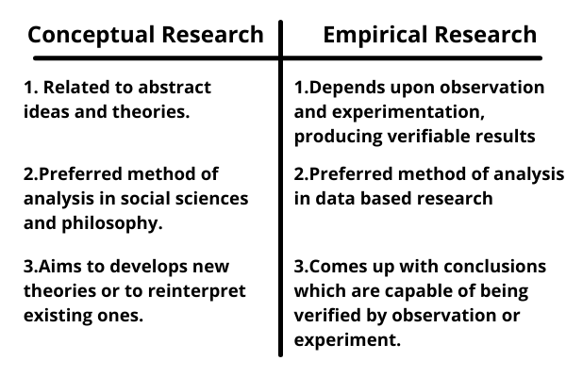Conceptual vs Empirical Research

***Conceptual Research:***

* Conceptual research is that related to some abstract idea or theory. It is generally used by philosophers and thinkers to develop new concept or to reinterpret existing ones.
* Conceptual analysis is the preferred method of analysis in social sciences and philosophy. Here, a researcher breaks down a theorem or concept into its constituent parts to gain a better understanding of the deeper philosophical issue concerning the theorem.

***Empirical Research:***

* Empirical depends upon observation and experimentation, and produces verifiable results.
* Empirical research is appropriate when proof is sought that certain variables affect other variables in some way.
* It is data-based research, coming up with conclusions which are capable of being verified by observation or experiment.
* We can also call it as experimental type of research